1. What is Tokenization in NLP?
Tokenization is the process of breaking raw text into smaller units called tokens.
These tokens are what the model actually processes.

1.1 Why Tokenization is Needed
Neural networks (like RNN/LSTM) cannot understand raw text.
They only work with numbers.
So we convert:
"I love machine learning"
into:
["I", "love", "machine", "learning"]

1.2 Types of Tokenization

1. Word-Level Tokenization
Splits text into words.
Example:
Input: "I love NLP"
Output: ["I", "love", "NLP"]
✅ Simple and intuitive
❌ Cannot handle unknown words well

1. Character-Level Tokenization
Splits text into characters.
"I love"
→ ["I", " ", "l", "o", "v", "e"]
✅ Handles any word
❌ Longer sequences → harder for LSTM

1.3 Subword Tokenization (Important)
Used in modern NLP.
Example:
"unhappiness"
→ ["un", "happi", "ness"]
Methods:
- BPE (Byte Pair Encoding)
- WordPiece
- SentencePiece
✅ Handles unknown words
✅ Efficient vocabulary size

2. What are Token IDs?
After tokenization, we convert tokens into numbers → called Token IDs.

2.1 Why Token IDs?
Models like LSTM/RNN cannot process words.
They need numerical representation.

2.2 Example
Sentence:
"I love NLP"
Vocabulary:
{
"I": 1,
"love": 2,
"NLP": 3
}
Token IDs:
[1, 2, 3]

2.3 Vocabulary (Very Important)
Vocabulary = mapping of tokens → IDs
Example:
word_index = {
"the": 1,
"cat": 2,
"sat": 3
}

2.4 Special Tokens
Used in NLP pipelines:
Token | Purpose
<PAD> | Padding shorter sequences
<UNK> | Unknown words
<START> | Start of sentence
<END> | End of sentence
Example:
"I love AI"
→ [<START>, 5, 6, 7, <END>]

3. Tokenization in LSTM / RNN Pipelines
Now let's connect this to your LSTM work.

3.1 Full Pipeline
Raw Text
→ Tokenization
→ Token IDs
→ Padding
→ Embedding
→ LSTM/RNN
→ Output

3.2 Step-by-Step Example
Step 1: Text
"I love deep learning"

Step 2: Tokenization
["I", "love", "deep", "learning"]

Step 3: Token IDs
[1, 2, 3, 4]

Step 4: Padding (Important for LSTM)
LSTM requires fixed-length sequences.
Example:
Max length = 6
[1, 2, 3, 4] → [0, 0, 1, 2, 3, 4]

3.3 Why Padding?
Because neural networks process batches, all inputs must have the same length.

4. Embedding Layer (Critical Concept)
Token IDs are integers, but LSTM needs vectors.
So we use an Embedding Layer.

4.1 What Embedding Does
It converts:
[1, 2, 3]
into:
[
[0.2, 0.8, 0.1],
[0.5, 0.3, 0.9],
[0.7, 0.6, 0.4]
]
Each word becomes a dense vector.

4.2 Why Embeddings?
They capture semantic meaning:
Example:
"king" ≈ "queen"
"car" ≈ "vehicle"

5. Tokenization in RNN vs LSTM
Tokenization is same, but usage differs slightly.

5.1 In RNN
- Sequential processing
- Sensitive to long sequences
- Tokenization must be efficient

5.2 In LSTM
- Handles long dependencies better
- Still requires:
  - Tokenization
  - Token IDs
  - Padding

6. Real Example Using Keras (Your Type of Code)
from tensorflow.keras.preprocessing.text import Tokenizer
from tensorflow.keras.preprocessing.sequence import pad_sequences
texts = ["I love NLP", "Deep learning is powerful"]
# Step 1: Tokenization
tokenizer = Tokenizer(num_words=1000)
tokenizer.fit_on_texts(texts)
# Step 2: Convert to token IDs
sequences = tokenizer.texts_to_sequences(texts)
print(sequences)
# Example output: [[1, 2, 3], [4, 5, 6, 7]]
# Step 3: Padding
padded = pad_sequences(sequences, maxlen=5)
print(padded)

7. Common Problems & Concepts

7.1 Out-of-Vocabulary (OOV)
New words not seen during training.
Solution:
Tokenizer(oov_token="<UNK>")

7.2 Vocabulary Size
Too large → slow
Too small → lose meaning

7.3 Sequence Length
- Too long → memory issues
- Too short → loss of context

8. Real-World Applications
Tokenization + Token IDs are used in:

8.1 Sentiment Analysis
"This movie is great"
→ tokens → IDs → LSTM → Positive

8.2 Machine Translation
"Hello"
→ tokens → LSTM → "Hola"

8.3 Chatbots
User input → tokens → IDs → model → response

8.4 Text Generation
Input: "Once upon a time"
→ LSTM predicts next words

9. Key Points
These are very important 👇
- Tokenization = splitting text into tokens
- Token IDs = numerical representation of tokens
- Vocabulary = mapping of token → ID
- Padding is required for LSTM
- Embedding converts IDs → vectors
- Handles OOV using <UNK>
- Subword tokenization is modern approach

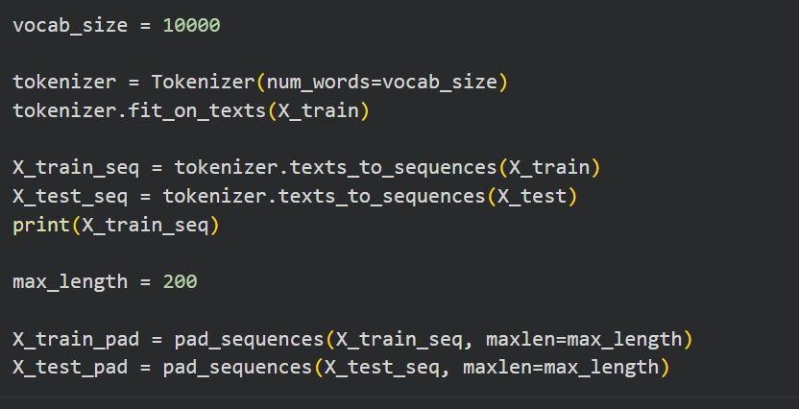
1. Define Vocabulary Size
vocab_size = 10000
✅ What it means:
You are limiting your model to top 10,000 most frequent words.

✅ Why we do this:
- Real-world text can have lakhs of unique words
- Using all words:
  - ❌ increases memory
  - ❌ slows training
- So we keep only the most important (frequent) words

🧠 Example:
If your dataset has:
["the", "is", "movie", "excellent", "fantabulous"]
Top frequent words might be:
["the", "is", "movie"]
Less frequent words → ignored or treated as unknown

🔹 2. Create Tokenizer
tokenizer = Tokenizer(num_words=vocab_size)
✅ What this does:
- Initializes a Tokenizer object
- It will:
  - Build vocabulary
  - Assign token IDs

⚙️ Important:
- num_words=10000 means:
Only top 10,000 words will be used when converting text → sequences

🔹 3. Fit Tokenizer on Training Data
tokenizer.fit_on_texts(X_train)
✅ What happens here:
Tokenizer learns vocabulary from your training data.

🔍 Internally it does:
- Splits text into words (tokenization)
- Counts frequency of each word
- Assigns index based on frequency

🧠 Example:
If:
X_train = ["I love NLP", "I love AI"]
Tokenizer creates:
word_index = {
"i": 1,
"love": 2,
"nlp": 3,
"ai": 4
}
👉 Most frequent word gets smallest index

⚠️ Important Rule:
You must ONLY fit on training data, NOT test data
→ avoids data leakage

🔹 4. Convert Training Text to Sequences
X_train_seq = tokenizer.texts_to_sequences(X_train)
✅ What this does:
Converts each sentence into list of token IDs

🧠 Example:
Input:
"I love NLP"
Output:
[1, 2, 3]

📌 Output structure:
[
[1, 2, 3],
[1, 2, 4],
...
]
👉 Each sentence becomes a list of integers

🔹 5. Convert Test Text to Sequences
X_test_seq = tokenizer.texts_to_sequences(X_test)
✅ What this does:
Same transformation for test data using same vocabulary

⚠️ Important:
- Uses vocabulary learned from training
- New words → ignored or mapped to OOV

🧠 Example:
If test sentence:
"I love Python"
and "Python" not in vocab:
Output:
[1, 2]
("Python" is dropped unless OOV token used)

🔹 6. Print Sequences
print(X_train_seq)
✅ Purpose:
- Debugging
- Understanding how text is converted

Example Output:
[[1, 5, 23], [2, 9], [4, 7, 8, 2]]

🔹 7. Define Maximum Sequence Length
max_length = 200
✅ What this means:
All sequences will be fixed to length = 200

✅ Why needed:
Neural networks (LSTM/RNN) require same input size

🧠 Example:
- Short sentence → padded
- Long sentence → truncated

🔹 8. Pad Training Sequences
X_train_pad = pad_sequences(X_train_seq, maxlen=max_length)
✅ What this does:
Makes all sequences same length = 200

🔍 How padding works:
Case 1: Short sequence
[1, 2, 3]
Becomes:
[0, 0, 0, ..., 1, 2, 3]
(added zeros in front → default is pre-padding)

Case 2: Long sequence
[1, 2, 3, 4, 5, ..., 300 words]
Becomes:
last 200 words only

⚙️ Default behavior:
- Padding: pre (add zeros at beginning)
- Truncating: pre (cut from beginning)

🔹 9. Pad Test Sequences
X_test_pad = pad_sequences(X_test_seq, maxlen=max_length)
✅ Same as training:
- Ensures test data also has same shape

🔥 Final Output Shape
After padding:
X_train_pad.shape → (num_samples, 200)
X_test_pad.shape → (num_samples, 200)

🔁 Full Pipeline Summary
Raw Text
↓
Tokenizer.fit_on_texts()
↓
texts_to_sequences()
↓
pad_sequences()
↓
LSTM Model Input

